phpCollab Team Manual
Copyright © Copyright (c) 2003 Michelle L. Feldman (phpCollab @ collabowrite.net) Permission is granted to copy, distribute and/or modify this document under the terms of the GNU Free Documentation License, Version 1.2 or any later version published by the Free Software Foundation; with no Invariant Sections, no Front-Cover Texts, and no Back-Cover Texts. A copy of the license is included in the section entitled "GNU Free Documentation License."

Table of Contents

Chapter 1. Getting Started
Section 1.1 Introduction and Features
Section 1.2. Log In
Section 1.3. Getting Oriented
Section 1.4. Icons
Chapter 2. Preferences
Section 2.1. User Profile
Section 2.2. Password
Section 2.3. Notifications
Chapter 3. Clients
Section 3.1. Add New Clients
Section 3.2. Edit Clients
Section 3.3. Add Client Users
Section 3.4. Edit Client Users
Chapter 4. Projects
Section 4.1. Add New Projects
Section 4.2. Edit Projects
Section 4.3. Build Project Team
Section 4.4. Manage Phases
Section 4.5. Add Tasks
Section 4.6. View, Edit, Delete Tasks
Section 4.7. Subtasks
Section 4.8. Add Discussions
Section 4.9. Post to/Close Discussions
Section 4.10. Notes
Section 4.11. Add Support Requests
Section 4.12. Manage Support Requests
Section 4.13. Export Projects
Chapter 5. Linked Content
Section 5.1. Add New Documents
Section 5.2. View/Save/Delete Documents
Section 5.3. Peer Reviews
Section 5.4. Update Documents
Chapter 6. Project Site
Section 6.1. Create Project Site
Section 6.2. Access Project Site
Section 6.3. Permit Client Users
Section 6.4. Client Use of Project Site
Section 6.5. Publish Items
Section 6.6. Delete Site
Chapter 7. Other Features
Section 7.1. Reports
Section 7.2. Search
Section 7.3. Calendar
Section 7.4. Bookmarks
Appendix A. GNU Free Documentation License

Chapter 1. Getting Started

Section 1.1. Introduction

PhpCollab is an open source internet-enabled system for use in projects that require collaboration over the internet. Those organizations, such as consulting firms, that rely on a division between firm-side and client-side information will benefit most from use of PhpCollab. The system is divided in two parts which we will call "Team Project Site" and "Client Project Site." The project team, excluding the client, has access to the Team Project Site. On the Team Project Site, users fall into several categories: Administrator, Manager, and User.
Administrators can maintain both business and technical aspects of the system. Managers administrate projects: they can add and edit clients, projects, project details, calendars, and reports but cannot upgrade the system, create new or change existing system users, or access the database. Users can view most information but can only add new discussions, notes, tasks, and linked content. The Team Project Site users also have access to the Client Project Site on the projects to which they are assigned.
Client users do not have access to the Team Project Site. When clients log in at the login page, they are directed to the Client Project Site. On this Site, they can approve or reject documents, file support requests, review tasks, or add a message to the bulletin board. Clients only have access to their own projects and cannot view or edit projects that belong to other clients. Clients also do not have access to those items that the project manager or other team member does not publish to the Client Project Site.
PhpCollab can be used on an intranet, an extranet, or both. This documentation will focus on the key aspects of the application - task and document management and client collaboration..

Features
- Team/Client: 2 distinct sites - one for project team information and one for client team information
- Notifications: automated notifications of project changes and events through email
- Project Lifecycle: customizable organization (through phases, tasks, and subtasks)
- Planning: manage assignments, monitor task status, track estimate vs actual work
- Graphical View: JPGraph graphically maps task progress
- Scope Creep: automatic display of difference between project estimates and recorded actuals
- Documents: file storage, versioning, peer reviews
- Support: manage and respond to support requests
- Bug Tracking: manage software issues through integrated Mantis
- Discussions: open and post to a project bulletin board
- Notes: record miscellaneous project information
- Reports: produce project statistics
- Calendar: visually track assignments and add milestones and recurring project events
- Bookmarks: record and share important web site addresses
- Search: search system on keyword basis
- Export: export project file to a comma-delimited file

Section 1.2. Log In

Enter the username and password (ask your system administrator if you do not know your username) in the log in screen.

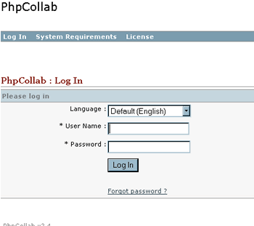

If you have forgotten your password, click on the "Forgot Password" link and enter your username on the next screen. The system will email a new password to you if your user profile contains your correct email address.

Section 1.3. Getting Oriented
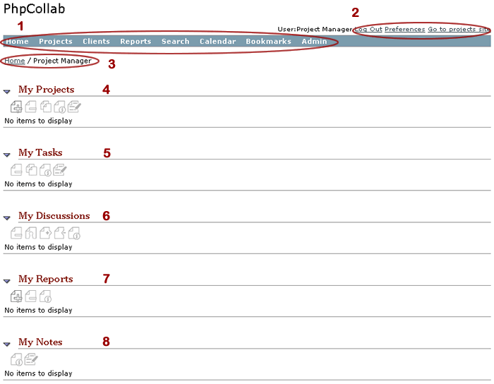

The Home Page (Figure 1.2) on the Team Project Site will appear after you have successfully logged in. Other team members will also see this home page but the client will see an entirely different page, which is discussed in Client Site and in Documentation for Clients. From this page, the manager or team member can access all aspects of the system except for the Menu Item labeled "Admin." "My Bookmarks" will appear above "My Projects" after the user has created bookmarks (project-related internet links).

- Main Navigation (items circled with "1" in Figure 1.2). This menu bar appears at the top of every page on the Internal Project Site. To return to the home page from any part of the Internal Project Site, click on the item labeled "Home" in this navigation. The user can also access all the major components of the site using this navigation.
- Top Right Navigation (items circled with "2" in Figure 1.2). These links appear in the top right corner of every page on the Team Project Site. The user can log out or edit/view preferences. To view the external Client Project Site, click "Go to Project Site."
- Location - the site user's location is listed under the Main Navigation ("3" in Figure 1.2), also known as a breadcrumb. In some cases, secondary page navigation will also appear here (such as in "Projects" where one can access "Inactive" Projects from Location).

Section 1.3. Getting Oriented (cont)

- My Projects - the user can see and access the list of current projects assigned to that user, or create new/ delete existing projects. The use can also access the list from "Projects" in the Main Navigation from anywhere on the Team Project Site. Continued....
- My Tasks - the user can see and access the list of current tasks assigned to that user, or delete existing tasks. The user can also access the task lists under each project by visiting that project's page.
- My Discussions - the user can see, access, delete/close, or publish the list of current "discussions" (or conversational postings) on assigned projects. The user can also access the discussions under each project by visiting that project's page.
- My Reports - the user can create new or delete existing project reports that include such information as outstanding tasks, status, and priority.
- My Notes - the user can view and edit existing notes.

Section 1.4. Icons

- "Add"
- "Delete"
- "Publish" > will add to Client Project Site
- "Unpublish" > will remove from Client Project Site
- "Edit"
- "View"
- "Copy"
- "Import"
- "Export" - saves to spreadsheet
- "Close Discussion" - disallows further posts to topic
- "Bug Tracking" - if Mantis is enabled

Conventions
There are mutliple methods for viewing and editing items in PhpCollab. To view an item, navigate to the list for that item. Some lists are are on the home page and/or in the Top Main Navigation (like “Projects”), and others (such as “Linked Content”) are only reachable by navigating to the owner item. Once you have reached the list of items, either click on the title of the item you want to open or click the checkbox next to the item and click the “View” button above the list (the former method is more direct).
To edit an item, you can either click on the checkbox next to the item title and then click the “edit” button above the list or you can go the main page for that item and click on the edit button at the top of that page. Your location should determine which method you choose for editing an item. For instance, if you are on the main page of a project (where the project's details are listed at the top of the page) you will probably want to click the edit button from there. However, if you are on the item list page (ie where all the projects are listed), then you should use the checkbox method as that is more direct than first viewing the item and editing from the main page.

Chapter 2. Preferences

Section 2.1. User Profile
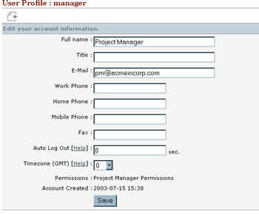

The user can reach "Preferences" by selecting the link in the Top Right Navigation. In the user profile you can specify:

- Full Name (as opposed to user name)
- Title
- Email (for notification purposes)
- Work, Home, Mobile, and Fax
- Log Out - time with no activity after which system will log user out; "0" disables this function
- Timezone (GMT): the numbers correspond to global timezones; postings by user will be timestamped according to timezone chosen
- Permission level and account creation date are listed as read-only values
- Only those users who are assigned to the user's projects can see the user's contact information and vice versa.

The user can export the values of his/her preferences to a comma-delimited file.

Section 2.2. Password

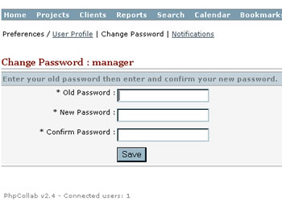

The system administrator initially creates usernames, passwords, and permissions. Once logged into the system, the user can change his/her password by selecting "Change Password" in "Preferences." If the user does not remember his/her password, he/she can have the password sent to his/her email address during the login process. If the user does not have an email address in the system, or does not recall his/her username, the user must request the password manually from the system administrator.

Section 2.3. Notifications

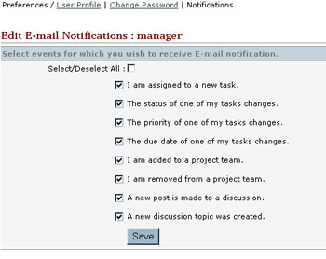

In the "Notifications" section of "Preferences," the user can choose whether to receive notifications via email (at the email address specified in "Profile"). All notifications is the system default. To decline notifications, the user can either leave the email address field (see "Profile") blank or uncheck all of the boxes by selecting the "Select/Deselect All." If the user wants to receive only a select group of notifications, he/she can choose on the basis of:

- new task assignment
- assigned task status, priority, or due date change
- new project assignment or removal
- new discussion topic or posting

Notifications will occur only on assigned projects.

Chapter 3. Clients

Section 3.1. Add New Clients

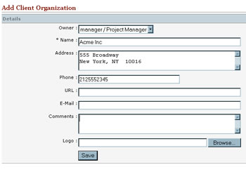

To create your first project in PhpCollab, you should initially create a client to which to attach the project (Note - you may create projects without client owners; if you want to create an internal project, create your own company as a client for optimal use of the system). Click on the "Clients" item of the Top Main Navigation, then click on the Add button on the "Client Organizations" Page. The Add Client Organization Page appears with the following fields:

- Owner - drop-down of existing team users; defaults to current user
- Name (required) - company name
- Address - company street address
- Phone - company telephone
- URL - company web site address
- Email - general company email address
- Comments
- Logo - company logo (if uploaded, will appear on Client Project Site)

Click the "Save" button when done.

Section 3.2. Edit Clients

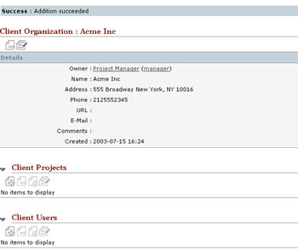

When you have saved your new client, the main "Client" Page will appear. This page provides information about the client and lists projects and client-side users (who will access the client site as opposed to the team site). You can edit the Client Organization's "Details" by clicking on the on the Edit button in the "Client Organization" Page or by selecting the checkbox next to the client's name in the "Clients" list on the "Client Organizations" Page and then clicking the Edit button above the list.

Section 3.3. Add Client Users

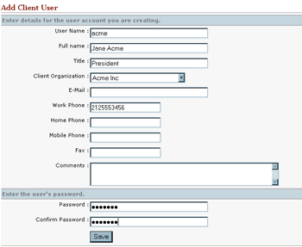

In order for your client users to log into their client site, you must first add the client to the Client Organization. Navigate to the main "Client Organization" Page for that client and scroll down to the section, "Client Users." Select the Add button in this section and the "Add Client User" Page will appear.

- User Name (required): Up to 16 characters - the name with which the client will login to the client site
- Full Name: Last and First Names
- Title: (optional) Client's job title
- Client Organization (required): Drop-down of existing client organizations in the system
- Email (optional): used for notifications
- Work, Home, Mobile, Fax Phone Numbers Comments
- Password (required): Up to 16 characters, letters, numbers, case-sensitive

Click the "Save" button when finished and the "Client Organization" Page will appear.

Section 3.4. Edit Client Users

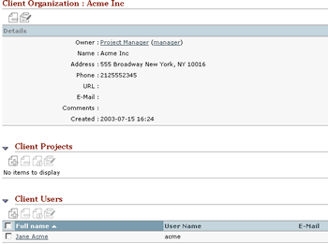

Once you have added a client user, you can edit this and other users for that client by navigating back to the "Client Organization" Page. Scroll down to the "Client User" section of the page and click on the name of the user whom you want to edit. The "Client User" Page will load and you will be able to edit all of the client user fields after clicking the Edit button. You can also directly access the "Edit Client User" screen by selecting the checkbox next to the user's name in the "Client User" list on the "Client Organization" Page and then clicking the Edit button above the list.

Click the "Save" button when you have finished.

You can also export the user's contact information to a "Vcard" file by clicking the Export button and then clicking "Save" on the resulting dialog box.

Chapter 4. Projects

Section 4.1. Add New Projects
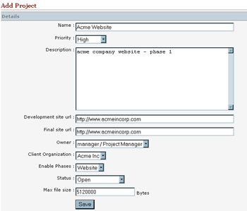

Once you have created the client to which to attach project, navigate to the "Projects" item in the top menu bar. Select the Add button above the list and the "Add Project" Page will appear.

- Project Name (required): Up to 50 characters
- Priority (optional): Very High, High, Medium, Low, Very Low
- Description (optional)
- Development Site URL: if using a testing site
- Final Site URL
- Owner (required): Drop-down of existing team users in the system
- Client Organization (optional): Drop-down of existing client organizations in the system
- Enable Phases (required): Drop-down of project types which will create certain phases (this can be customized)
- Status (optional): Not Started, Open, Suspended, Client Completed, Completed
- Max file size: defaults to system-wide setting; set to larger size if you know that you will be uploading large files during the course of the project or smaller if you want to conserve space and limit user uploads (have the sys admin reset the maximum allowable file size for the system)

Click the “Save” button when finished.

Section 4.2. Edit Projects

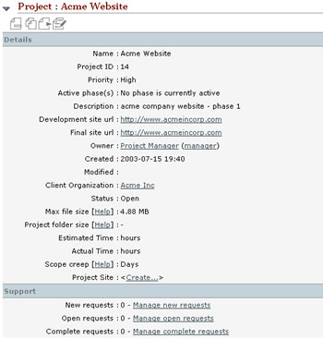

When you have saved your new project, the main "Project" Page will appear. This page provides:

- Project Details
- Project Site Create
- Support requests information
- Discussions
- Team members list
- Linked Content (documents)
- Notes

You can edit the Project "Details" by clicking on the Edit button on the "Project" Page or by selecting the check box next to the project's name in the "Projects" list on the "Projects" Page and then clicking the Edit button above the list.

Section 4.3. Build Project Team

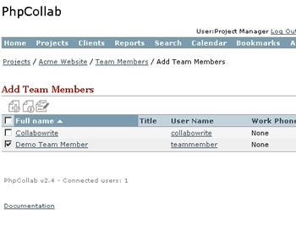

To add members of your own organization to a project, the user must already exist in the system. Only a system administrator can create new non-client team users. To add an existing user to your team, navigate to the "Project" Page for the project to which you want add team members. Scroll down to the "Team" section in the middle of this page. Click on the Add button above the "team" member list, and the "Add Team Members" Page will appear. Select the checkbox next to the desired user's "Full Name" field then click the Add button above the list. You can also add multiple team members at the same time by checking all desired names and then clicking the "Add" button.

After adding a team member, the "Project" Page will load with the team member listed in the "Team" section. To view the details of the team member, either click on the user's name or select the checkbox next to the desired user's "Full Name" field then click the View button above the list. To delete a team member from the project, select the checkbox next to the desired user's "Full Name" field then click the Delete button above the list.

Section 4.4. Manage Phases

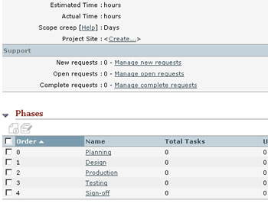

All projects in PhpCollab follow a project lifecycle methodology, meaning that they are broken down into phases, then tasks, then subtasks. Your system administrator can customize these phases, in terms of number, order, and names. When you create the project, the "Enable Phases" type you choose will automatically create the pre-determined set of phases in your new project (Note: you can also choose not to enable phases at all.)

You can edit the information pertaining to a particular phase by clicking on the name of the phase in the "Phases" section of the main "Project" Page for that project, and then clicking the Edit button when you reach the "Phase" Page. You can also select the checkbox next to the phases's name and then click the Edit button above the list.

Section 4.5. Add Tasks
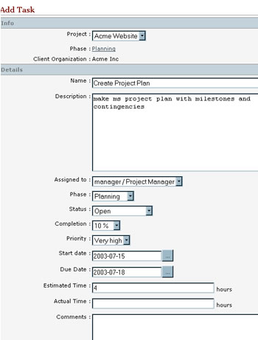
Each phase of your project should contain tasks, which in turn can contain sub-tasks. To add a new task, navigate to the "Phase" Page and scroll down to the "Tasks" section. Click on the Add button above the list of tasks, and the "Add Task" Page will appear. You can edit the following fields:
- Project (required): Drop-down of existing projects in the system
- Task Name (required): short title of task (ie - "Create Site Map")
- Description
- Assigned To (optional): Drop-down of team members on that project and client users if added to client site
- Phase (required): list of phases enabled for that project
- Status (required): Not Started, Open, Suspended, Completed, Client Completed
- Start Date (optional): the Calendar button opens a calendar from which to choose a day
- Due Date (optional): this is a projected not an actual date
- Estimated Time (optional): in hours
- Actual Time (optional)
- Comments (optional)
- Publish check box - you may publish the task if you have already created the client site
Click the "Save" button when finished and the "Task" Page will appear.

Section 4.6. View, Edit, Delete Tasks

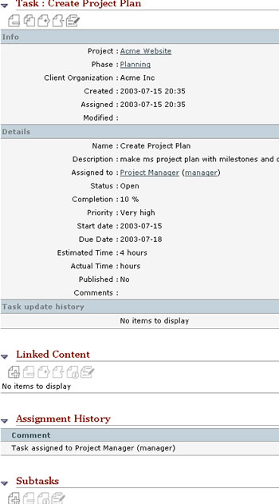

Continued…

Section 4.6. View, Edit, Delete Tasks (cont)

VIEW: To view task information, click on the "Task" name field in the list on the "Phases" Page. You can also view tasks assigned to you by navigating to the Home Page and clicking on the task's name in the "My Tasks" section. The "Task" Page will load, containing the following sections:

- Task Info
- Details
- Update History
- Linked Content: documents that are assigned only to the task
- Assignment History: if the tasks has been assigned to multiple users, the dates, users assigned, and comments will appear here
- Subtasks

EDIT :
To edit main task information, click on the Edit button on the "Task" Page or select the checkbox next to the task's name in the "Task" section on the "Phase" Page and then clicking the Edit button above the list. You can edit all the details of the task in "Add Task" except for the Phase and Client Organization. You can also now edit complete date (actual date of completion) and assignment history comments.
Press the "Save" button when finished.

DELETE:
To delete a task from a phase, click the button on the task's "Task" Page. You can also delete the task from the "Phase" Page by selecting the checkbox next to the task's name in the "Tasks" section and then clicking the Remove button above the list.

Section 4.7. Subtasks

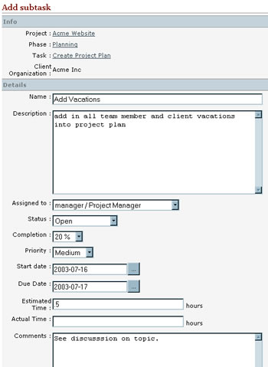

ADD:
In a complex project, one can further subdivide tasks into subtasks. To create a new subtask, navigate to the "Task" Page for the parent task and scroll down to the "Subtasks" section. Click on the button above the list in this section and the "Add Subtask" Page will appear. This page contains exactly the same fields as the "Add Task" Page.
Press the "Save" button when finished.

VIEW, EDIT, DELETE:
Once you have saved a subtask, you may view it by clicking on the subtask name in the "Subtasks" section of the "Task" Page. To edit main task information, click on the button on the "Subtask" Page or select the check box next to the subtask's name in the "Subtask" section on the "Task" Page and then clicking the Edit button above the list. See Edit Tasks for details of viewing, editing, and deleting substasks.

Section 4.8. Add Discussions

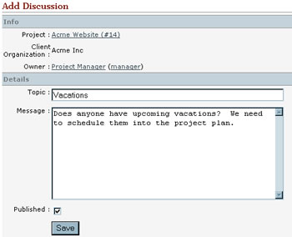

Instead of constantly sending emails and losing track of these important chains of communication, document exchanges using the discussion feature in PhpCollab. Team members and clients can initiate discussions; the team can also conduct discussions without including the client (by not publishing).
To add a discussion to your project, navigate to the "Discussions" Section at the bottom of the "Project" Page. Click on the Add button above the discussions list. Enter the Topic, and Message on the "Add Discussion" Page.
To include the client in the discussion by publishing to the client site, select the Publish checkbox.
Click the "Save" button when finished.

Section 4.9. Post to/Close Discussions

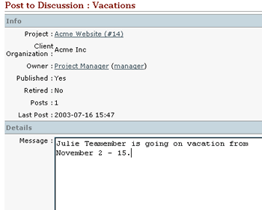

To post to a discussion, scroll down to the "Discussions" section of the "Project" Page and click on the discussion to which you want to post. When the Discussion page appears, click on the "Post Reply" link in the "Posts" section. Add text in the Message area and click the "Save" button (Note: You cannot currently edit a saved post).

You may close the discussion by clicking the button from the main "Discussion" Page. Closing, unlike deleting, leaves a record of the discussion in the system (Note: only the discussion creator can close or delete the discussion).

To delete a discussion entirely, select the button at the top of the "Discussion" Page. Closing, deleting, publishing, and unpublishing can also be done from the "Project" Page under the "Discussions" section.

Section 4.10. Notes

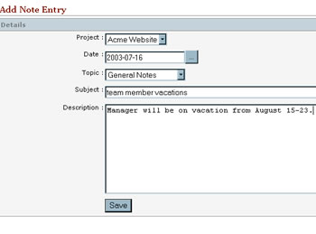

To keep a brief record of a meeting or phone conversation or to call something to the team's attention, use the note feature of PhpCollab. To add a note to your project, navigate to the "Notes" section at the bottom of the "Project" Page. Click on the Add button above the notes list. Notes have the following fields:

- Project: List of existing projects in the system
- Date: date of entry (click the Calendar button for a calendar)
- Topic: Phone Conversation, General Notes, Conference Notes (your sys admin can customize these)
- Subject
- Description: actual content of note

Click the "Save" button when finished.
Edit the note by clicking the Edit button on the "Note" Page or by selecting the checkbox next to the note's name in the "Notes" list on the "Projects" Page and then clicking the Edit button above the list.

Section 4.11. Add Support Requests

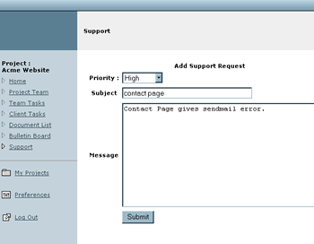

When a client experiences technical or other issues, he or she can file a support request through the Project Site interface. A team member may also file a request through the project site by clicking on the link "Go to Project Site" at the top of any team site page, selecting the appropriate project, and clicking on "Support" on the left-hand side of the page. The "Add Support Request" Page will appear with following fields:

- Priority (Very Low, Low, Medium, High, Very High)
- Subject
- Message

After clicking the "Submit" button, the "Support" results page will appear and give the team member an opportunity to respond immediately with a support response.

Section 4.12. Manage Support Requests

After a team member or client has filed a support request, a team member can add information to the request, change the request's status, and close the request out. The "Support" Section is under "Details" on the Project's main page. The Support Section lists the type and number of requests in the queue: new, open, and complete. To manage a request of any of the three types, click on the "Manage..." link and a list of incidents for that type will appear.

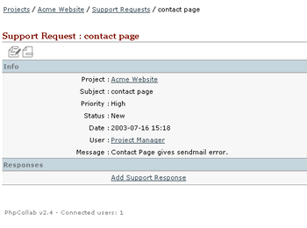

To view or edit an incident, click on the title of that incident. From here you can:

- Change the status of the incident by clicking the Edit button (New, Open,Complete)
- Click the "Add a Support Response" link to enter a resolution, questions, or comments
- Delete the support incident by clicking the Remove button
- Close the incident by changing its status to "Complete"

Click the “Save” button when finished editing an incident.

Section 4.13. Export Projects

The export feature currently only takes information from projects and saves it locally as a comma-separated values file. The manual will cover exporting when this feature includes exporting to MSProject (slated for PhpCollab 3.0).

Chapter 5. Linked Content

Section 5.1. Add New Documents

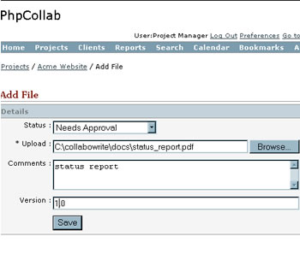

Workflow is a major component in PhpCollab. The "Linked Content" area of a project centralizes documents, allows for assignments and approvals, and enables versioning and review. You may add a document of any kind here, so long as it does not exceed the file size limits (the project manager can set file size limits in the project's details).
To add a new file, navigate to the desired project's home page and click the "Add" button under "Linked Content."

- Status (approvals) - Approved, Approved with Changes, Needs Approval, No Approvals Needed, Not Approved
- Location - use "Browse" button to locate the document
- Comments
- Version Number

Click the "Save" button to complete the upload of the new document.

Section 5.2. View/Save/Delete Documents
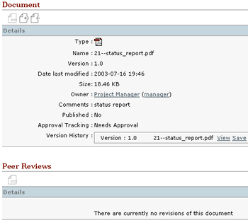

To view or save a document to your local computer, navigate to the Linked Content section of the project to which the document belongs and click on the document's title. The main "Document" Page will load with the following sections:

- Details - lists the document type, name, version, size, owner, comments, publish status, approval status, and version history
- Peer Reviews- shows history of peer reviews; allows for peer review uploading with comments
- Upload Document - allows for upload of document owner's update with comments and version number

To view the document, click on the "View" link in the Version History section of Details then click the "Open" button on the dialog box that appears. To download the document, click on the "Save" link in the same section, click "Save" on the dialog box and choose the location on your local computer to which to save the document.

To delete a document from the system, click the checkbox next to the document title in the "Linked Content" section then click the Remove button, or click the Remove button from the document's main page. Use the Unpublish button to only remove the document from the client Project Site. Note: only the creator of a document can delete the document; currently, deleting the document deletes all peer reviews and updates associated with the document as well.

Section 5.3. Peer Reviews

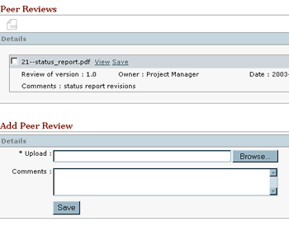

Once a team member or client has added a document, other team members can add edits of the document in the Peer Review section of the document's main page. Under "Add Peer Review," click the "Browse" button. Add any comments desired.
Once you have clicked the "Save" button, the document's home page will load and you may now view or save (download) the peer review from the "Peer Reviews" Section.
To view the peer review, click the "View" link in this section, then click the "Open" button in the dialog box that appears.
To download the peer review to your local computer, click the "Save" link in this section, click the "Save" button in the dialog box, then choose the location to which to save the peer review to your local computer.
To delete the peer review, select the checkbox next to the peer review's title, then click the Remove button above.

Section 5.4. Update Documents

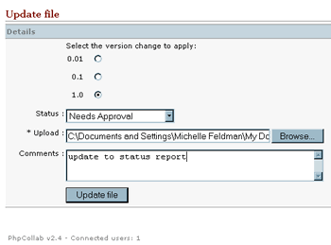

The author of a document may make his/her own changes or incorporate peer review comments into an existing document. To update the file, navigate to the document's main page and scroll down to the "Update file" Section, which has the following fields:

- Version - attach a new version number according to one of three numbering schemes (ie - if the original was 1.0, and you choose "1.0" in version here, the version of the update will be 2.0)
- Status - (approvals) Approved, Approved with Changes, Needs Approval, No Approvals Needed, Not Approved
- Upload - use the "Browse" button to locate the updated file on your hard drive
- Comments

After you have clicked on "Update File" button, the document's main page will load, listing the newly updated document in "Version History" under the Details section.
To view the update, click the "View" link in this section, then click the "Open" button in the dialog box that appears.
To download the update to your local computer, click the "Save" link in this section, click the "Save" button in the dialog box, then choose the location to which to save the update to your local computer. Note: updates cannot currently be deleted or unpublished.

Chapter 6. Project Site

Section 6.1. Create Project Site
As was explained in the Introduction to this manual, PhpCollab has two primary components: team site and client site. The client site allows your clients to login and see only their project or projects. Furthermore, you can control the documents, assignments, and discussions are available to the client.

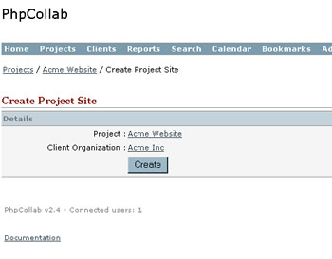

PhpCollab does not automatically create a site when you add a project. To create the client site, navigate to the home page of the project. Scroll down to the last item, titled "Project Site," in the Details Section and click on the "Create" link. The "Create Project Site" Page will appear listing the Project's name and the client organization (if selected).
Click the "Create" button to create the project site.

Section 6.2. Access Project Site

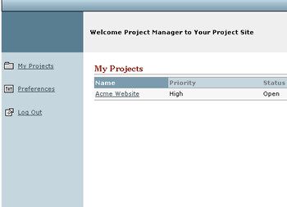

A team member can access the Project Site from anywhere within the team site by clicking on the "Go to Project Site" link in the top right hand corner of any page.

The Project Site will load in a new window with a list of projects in the main body of the page and navigation on the left-hand side. To learn about navigating the client site, see PhpCollab for Clients documentation. (Note: team members will only see projects to which they are assigned.)

In order for team members to see Project items on the client site, the project manager must first publish the team member by selecting the checkbox next to the team member's name in the "Team" Section of the project's main page and clicking the "Publish" button above.

Section 6.3. Permit Client Users
In order for clients to use this site, you must first add client users to the organization listed as the client for that project, if you have not already done so (see "Add Client Users"). Then add these client users to the project team by navigating to the project's home page and scrolling down to the last item, Project Site, under Details, and click on the "Details" link.

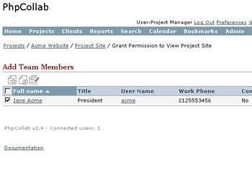
When the "Project Site" Page for that project appears, scroll down to the "Permitted Client Users" section, and click on the Add button. When the "Add Team Members" Page appears, click on the checkbox next to the name of the client user you want to add and click the Add button again.

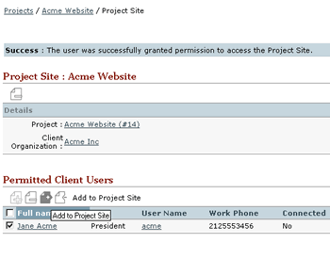

The client user can now login to the client site but will not be able to add or edit items until you publish that user. To publish a client user, navigate to the Permitted Client Users Section of the Project Site Page. Click next to the name of the user to be published and click on the Publish button.

Section 6.4. Client Use of Project Site

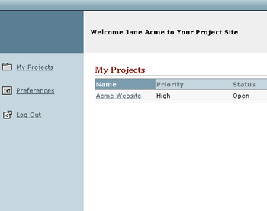

When the client user logs into phpCollab, the project site home page will load, rather than the team site.
The Client user will have read-only access to the following items:
- Project Details;
- Project Team; and
- Client Tasks.

Client users will be able to freely add to:
- Document List (same as Linked Content);
- Bulletin Board (same as Discussions); and
- Support.

Clients will be able to post tasks under "Team Tasks." However, in order for the task to appear in the client site, the project manager must log into the team site and navigate to where the task is posted (generally to the most current open phase of the project). Edit the task and assign it to the appropriate team or client user, then publish.

Section 6.5. Publish Items
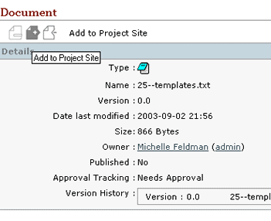
In order to see any of the work posted to the team site, team users must publish items to the client site.

After adding any item, such as a document or a task, the user can publish the item by either navigating to the section that contains the item or by going into the main page for that item. If working from a section, select the checkbox next to the item's name then click the Publish button. If working from the item's home page, simply click the Publish Button at the top of the page. The item will now appear in its appropriate section in the client site.

To remove an item from the client site but retain it in the system, use the Unpublish button. The Unpublish button is located in the same places as the Publish button and is used in the same manner.

Section 6.6. Delete Site

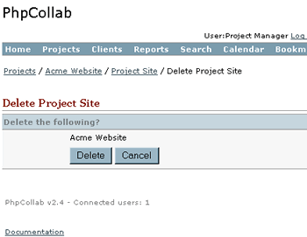

If you decide to remove the project site but wish to retain the project as active on the team site, delete the project site. To delete or unpublish the project site, navigate to the project's home page on the team site, scroll down to the "Publish Site" item at the bottom of the Details Section and click the "Details" Link. When the Project Site Page appears, click the Delete button above the Details Section. The "Delete Project Site" Page will appear asking for confirmation of the delete. Click the "Delete" button to proceed. The project home page will reload with confirmation of the project site removal.

Chapter 7. Other Features

Section 6.1. Reports

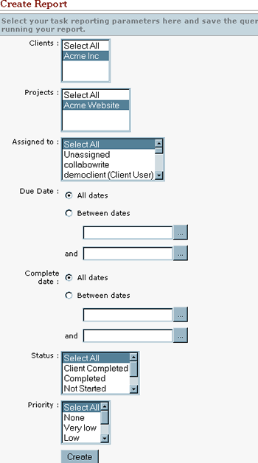

The Reports feature in PhpCollab can be useful in preparing for status meetings and for compiling new task lists. To put together a report, click on the "Reports" item in the main navigation, located at the top of every page on the team site.

Continued...

Section 6.1. Reports (cont)
The "Create Report" Page appears with the following fields (all fields default to the "Select All" value):

- Clients - list of Client Organizations in system
- Projects - list of projects in the system
- Assigned To - list of all team and client users (including "Unassigned")
- Due Date - projected date complete; choose either All Dates or enter date range in Between Dates fields
- Complete Date - actual date complete; choose either All Dates or enter date range in Between Dates fields
- Status - Client Completed, Completed, Not Started, Open, Suspended
- Priority - None, Very low, Low, Medium, High, Very high

Note: the user creating the report may only choose values associated with the projects to which he/she is assigned.

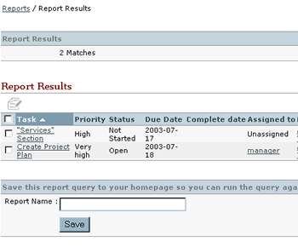

Click the "Create" button and the "Report Results" Page will load with the results produced from the parameters you selected in the previous step. You may edit the report by clicking the Edit button. To save the report, type the desired report and the report parameters will be saved. The report will then be accessible from either the My Reports section in the home page or the Reports item in the main navigation. You may also edit or delete the report from there.

Note: saving the report saves the parameters and not the results - therefore if your updates of a project or client impact the report, the results will change the next time you view the report.

Section 6.2. Search

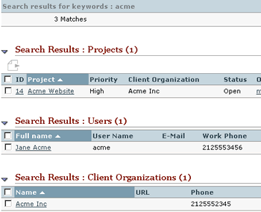

PhpCollab has a site-wide search facility that allows you to comb the site for words or phrases. To search the team PhpCollab installation, click on "Search" in the main navigation located at the top of every page. The "Search" Page will load, asking for keywords.

You can also specify where in PhpCollab you want to conduct the search (All content, Notes, Client Organizations, Projects, Tasks, Discussions, Users). If you choose "All Content," the search items will appear categorized under their appropriate headings (ie - "Notes").

The "Search Results" Page contains all categorized results and allows the user to search again at the bottom of the results.

Section 6.3. Calendar
PhpCollab contains a calendaring component, which is integrated with project tasks and allows the user to manually add items only to the calendar. The calendar is optimal for meetings, milestones/deliverables, and other events.

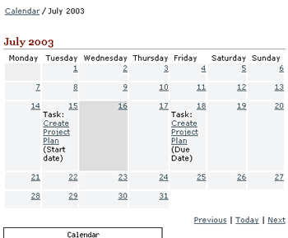

To add an event to the calendar, click on "Calendar" in the main navigation, located at the top of every page. The current month page will load - to add an event to a different month, click on the "Previous" or "Next" link at the bottom left of the page. Click on the day link located in the top right hand corner of every day on the calendar page. The main page for that day will appear - click the Add button.

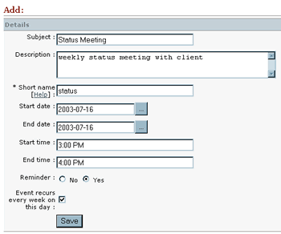

Continued...

Section 6.3. Calendar (cont)
The "Add Event" Page will appear with the following fields:

- Subject (the long name of the event)
- Description
- Short Name (required - will appear in the day)
- Start date (defaults to day you selected) - change manually or using calendar button
- End date(defaults to day you selected) - change manually or using calendar button
- Start Time
- End Time
- Reminder (Yes or No)
- Event recurs... (Checkbox) - Note: there is no ability to change the end date or type for recurrence

Click the "Save" button to add the event.
To edit the event, navigate back to the calendar day page, click the box next to the event and click the Edit button. To delete the event, click the Remove button in the same manner.
You can also export the event as an iCalendar file using the Export button. Note: there is no ability currently to publish to or view the calendar on the Project Site.

Section 6.4. Bookmarks
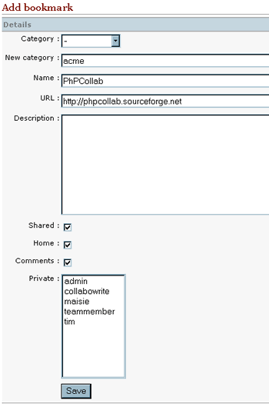

To keep track of website addresses associated with your projects, use the bookmarking function. Click on the "Bookmarks" item in the main navigation, located at the top of every page on the team site. The "Add Bookmark" Page will appear with the following fields:
- Category
- New Category - adds a new category to the above drop-down
- Name
- URL
- Description
- Shared (checkbox) - all team members see
- Home (checkbox) - puts bookmark under "My Bookmarks" on your home page
- Comments (checkbox) - not currently functional
- Private - select from list of team members if you want only limited sharing

Click the "Save" button and the Bookmarks page will load listing the new bookmark. Use the Edit button to edit or the Remove button to delete.

Appendix A. GNU Free Documentation License
Version 1.2, November 2002 Copyright (C) 2000,2001,2002 Free Software Foundation, Inc. 59 Temple Place, Suite 330, Boston, MA 02111-1307 USA Everyone is permitted to copy and distribute verbatim copies of this license document, but changing it is not allowed.
0. PREAMBLE The purpose of this License is to make a manual, textbook, or other functional and useful document "free" in the sense of freedom: to assure everyone the effective freedom to copy and redistribute it, with or without modifying it, either commercially or noncommercially. Secondarily, this License preserves for the author and publisher a way to get credit for their work, while not being considered responsible for modifications made by others. This License is a kind of "copyleft", which means that derivative works of the document must themselves be free in the same sense. It complements the GNU General Public License, which is a copyleft license designed for free software. We have designed this License in order to use it for manuals for free software, because free software needs free documentation: a free program should come with manuals providing the same freedoms that the software does. But this License is not limited to software manuals; it can be used for any textual work, regardless of subject matter or whether it is published as a printed book. We recommend this License principally for works whose purpose is instruction or reference.
1. APPLICABILITY AND DEFINITIONS This License applies to any manual or other work, in any medium, that contains a notice placed by the copyright holder saying it can be distributed under the terms of this License. Such a notice grants a world-wide, royalty-free license, unlimited in duration, to use that work under the conditions stated herein. The "Document", below, refers to any such manual or work. Any member of the public is a licensee, and is addressed as "you". You accept the license if you copy, modify or distribute the work in a way requiring permission under copyright law. A "Modified Version" of the Document means any work containing the Document or a portion of it, either copied verbatim, or with modifications and/or translated into another language. A "Secondary Section" is a named appendix or a front-matter section of the Document that deals exclusively with the relationship of the publishers or authors of the Document to the Document's overall subject (or to related matters) and contains nothing that could fall directly within that overall subject. (Thus, if the Document is in part a textbook of mathematics, a Secondary Section may not explain any mathematics.) The relationship could be a matter of historical connection with the subject or with related matters, or of legal, commercial, philosophical, ethical or political position regarding them. The "Invariant Sections" are certain Secondary Sections whose titles are designated, as being those of Invariant Sections, in the notice that says that the Document is released under this License. If a section does not fit the above definition of Secondary then it is not allowed to be designated as Invariant. The Document may contain zero Invariant Sections. If the Document does not identify any Invariant Sections then there are none. The "Cover Texts" are certain short passages of text that are listed, as Front-Cover Texts or Back-Cover Texts, in the notice that says that the Document is released under this License. A Front-Cover Text may be at most 5 words, and a Back-Cover Text may be at most 25 words. A "Transparent" copy of the Document means a machine-readable copy, represented in a format whose specification is available to the general public, that is suitable for revising the document straightforwardly with generic text editors or (for images composed of pixels) generic paint programs or (for drawings) some widely available drawing editor, and that is suitable for input to text formatters or for automatic translation to a variety of formats suitable for input to text formatters. A copy made in an otherwise Transparent file format whose markup, or absence of markup, has been arranged to thwart or discourage subsequent modification by readers is not Transparent. An image format is not Transparent if used for any substantial amount of text. A copy that is not "Transparent" is called "Opaque". Examples of suitable formats for Transparent copies include plain ASCII without markup, Texinfo input format, LaTeX input format, SGML or XML using a publicly available DTD, and standard-conforming simple HTML, PostScript or PDF designed for human modification. Examples of transparent image formats include PNG, XCF and JPG. Opaque formats include proprietary formats that can be read and edited only by proprietary word processors, SGML or XML for which the DTD and/or processing tools are not generally available, and the machine-generated HTML, PostScript or PDF produced by some word processors for output purposes only. The "Title Page" means, for a printed book, the title page itself, plus such following pages as are needed to hold, legibly, the material this License requires to appear in the title page. For works in formats which do not have any title page as such, "Title Page" means the text near the most prominent appearance of the work's title, preceding the beginning of the body of the text. A section "Entitled XYZ" means a named subunit of the Document whose title either is precisely XYZ or contains XYZ in parentheses following text that translates XYZ in another language. (Here XYZ stands for a specific section name mentioned below, such as "Acknowledgements", "Dedications", "Endorsements", or "History".) To "Preserve the Title" of such a section when you modify the Document means that it remains a section "Entitled XYZ" according to this definition. The Document may include Warranty Disclaimers next to the notice which states that this License applies to the Document. These Warranty Disclaimers are considered to be included by reference in this License, but only as regards disclaiming warranties: any other implication that these Warranty Disclaimers may have is void and has no effect on the meaning of this License.
2. VERBATIM COPYING You may copy and distribute the Document in any medium, either commercially or noncommercially, provided that this License, the copyright notices, and the license notice saying this License applies to the Document are reproduced in all copies, and that you add no other conditions whatsoever to those of this License. You may not use technical measures to obstruct or control the reading or further copying of the copies you make or distribute. However, you may accept compensation in exchange for copies. If you distribute a large enough number of copies you must also follow the conditions in section 3. You may also lend copies, under the same conditions stated above, and you may publicly display copies.
3. COPYING IN QUANTITY If you publish printed copies (or copies in media that commonly have printed covers) of the Document, numbering more than 100, and the Document's license notice requires Cover Texts, you must enclose the copies in covers that carry, clearly and legibly, all these Cover Texts: Front-Cover Texts on the front cover, and Back-Cover Texts on the back cover. Both covers must also clearly and legibly identify you as the publisher of these copies. The front cover must present the full title with all words of the title equally prominent and visible. You may add other material on the covers in addition. Copying with changes limited to the covers, as long as they preserve the title of the Document and satisfy these conditions, can be treated as verbatim copying in other respects. If the required texts for either cover are too voluminous to fit legibly, you should put the first ones listed (as many as fit reasonably) on the actual cover, and continue the rest onto adjacent pages. If you publish or distribute Opaque copies of the Document numbering more than 100, you must either include a machine-readable Transparent copy along with each Opaque copy, or state in or with each Opaque copy a computer-network location from which the general network-using public has access to download using public-standard network protocols a complete Transparent copy of the Document, free of added material. If you use the latter option, you must take reasonably prudent steps, when you begin distribution of Opaque copies in quantity, to ensure that this Transparent copy will remain thus accessible at the stated location until at least one year after the last time you distribute an Opaque copy (directly or through your agents or retailers) of that edition to the public. It is requested, but not required, that you contact the authors of the Document well before redistributing any large number of copies, to give them a chance to provide you with an updated version of the Document.
4. MODIFICATIONS You may copy and distribute a Modified Version of the Document under the conditions of sections 2 and 3 above, provided that you release the Modified Version under precisely this License, with the Modified Version filling the role of the Document, thus licensing distribution and modification of the Modified Version to whoever possesses a copy of it. In addition, you must do these things in the Modified Version: A. Use in the Title Page (and on the covers, if any) a title distinct from that of the Document, and from those of previous versions (which should, if there were any, be listed in the History section of the Document). You may use the same title as a previous version if the original publisher of that version gives permission. B. List on the Title Page, as authors, one or more persons or entities responsible for authorship of the modifications in the Modified Version, together with at least five of the principal authors of the Document (all of its principal authors, if it has fewer than five), unless they release you from this requirement. C. State on the Title page the name of the publisher of the Modified Version, as the publisher. D. Preserve all the copyright notices of the Document. E. Add an appropriate copyright notice for your modifications adjacent to the other copyright notices. F. Include, immediately after the copyright notices, a license notice giving the public permission to use the Modified Version under the terms of this License, in the form shown in the Addendum below. G. Preserve in that license notice the full lists of Invariant Sections and required Cover Texts given in the Document's license notice. H. Include an unaltered copy of this License. I. Preserve the section Entitled "History", Preserve its Title, and add to it an item stating at least the title, year, new authors, and publisher of the Modified Version as given on the Title Page. If there is no section Entitled "History" in the Document, create one stating the title, year, authors, and publisher of the Document as given on its Title Page, then add an item describing the Modified Version as stated in the previous sentence. J. Preserve the network location, if any, given in the Document for public access to a Transparent copy of the Document, and likewise the network locations given in the Document for previous versions it was based on. These may be placed in the "History" section. You may omit a network location for a work that was published at least four years before the Document itself, or if the original publisher of the version it refers to gives permission. K. For any section Entitled "Acknowledgements" or "Dedications", Preserve the Title of the section, and preserve in the section all the substance and tone of each of the contributor acknowledgements and/or dedications given therein. L. Preserve all the Invariant Sections of the Document, unaltered in their text and in their titles. Section numbers or the equivalent are not considered part of the section titles. M. Delete any section Entitled "Endorsements". Such a section may not be included in the Modified Version. N. Do not retitle any existing section to be Entitled "Endorsements" or to conflict in title with any Invariant Section. O. Preserve any Warranty Disclaimers. If the Modified Version includes new front-matter sections or appendices that qualify as Secondary Sections and contain no material copied from the Document, you may at your option designate some or all of these sections as invariant. To do this, add their titles to the list of Invariant Sections in the Modified Version's license notice. These titles must be distinct from any other section titles. You may add a section Entitled "Endorsements", provided it contains nothing but endorsements of your Modified Version by various parties--for example, statements of peer review or that the text has been approved by an organization as the authoritative definition of a standard. You may add a passage of up to five words as a Front-Cover Text, and a passage of up to 25 words as a Back-Cover Text, to the end of the list of Cover Texts in the Modified Version. Only one passage of Front-Cover Text and one of Back-Cover Text may be added by (or through arrangements made by) any one entity. If the Document already includes a cover text for the same cover, previously added by you or by arrangement made by the same entity you are acting on behalf of, you may not add another; but you may replace the old one, on explicit permission from the previous publisher that added the old one. The author(s) and publisher(s) of the Document do not by this License give permission to use their names for publicity for or to assert or imply endorsement of any Modified Version.
5. COMBINING DOCUMENTS You may combine the Document with other documents released under this License, under the terms defined in section 4 above for modified versions, provided that you include in the combination all of the Invariant Sections of all of the original documents, unmodified, and list them all as Invariant Sections of your combined work in its license notice, and that you preserve all their Warranty Disclaimers. The combined work need only contain one copy of this License, and multiple identical Invariant Sections may be replaced with a single copy. If there are multiple Invariant Sections with the same name but different contents, make the title of each such section unique by adding at the end of it, in parentheses, the name of the original author or publisher of that section if known, or else a unique number. Make the same adjustment to the section titles in the list of Invariant Sections in the license notice of the combined work. In the combination, you must combine any sections Entitled "History" in the various original documents, forming one section Entitled "History"; likewise combine any sections Entitled "Acknowledgements", and any sections Entitled "Dedications". You must delete all sections Entitled "Endorsements."
6. COLLECTIONS OF DOCUMENTS You may make a collection consisting of the Document and other documents released under this License, and replace the individual copies of this License in the various documents with a single copy that is included in the collection, provided that you follow the rules of this License for verbatim copying of each of the documents in all other respects. You may extract a single document from such a collection, and distribute it individually under this License, provided you insert a copy of this License into the extracted document, and follow this License in all other respects regarding verbatim copying of that document.
7. AGGREGATION WITH INDEPENDENT WORKS A compilation of the Document or its derivatives with other separate and independent documents or works, in or on a volume of a storage or distribution medium, is called an "aggregate" if the copyright resulting from the compilation is not used to limit the legal rights of the compilation's users beyond what the individual works permit. When the Document is included in an aggregate, this License does not apply to the other works in the aggregate which are not themselves derivative works of the Document. If the Cover Text requirement of section 3 is applicable to these copies of the Document, then if the Document is less than one half of the entire aggregate, the Document's Cover Texts may be placed on covers that bracket the Document within the aggregate, or the electronic equivalent of covers if the Document is in electronic form. Otherwise they must appear on printed covers that bracket the whole aggregate.
8. TRANSLATION Translation is considered a kind of modification, so you may distribute translations of the Document under the terms of section 4. Replacing Invariant Sections with translations requires special permission from their copyright holders, but you may include translations of some or all Invariant Sections in addition to the original versions of these Invariant Sections. You may include a translation of this License, and all the license notices in the Document, and any Warranty Disclaimers, provided that you also include the original English version of this License and the original versions of those notices and disclaimers. In case of a disagreement between the translation and the original version of this License or a notice or disclaimer, the original version will prevail. If a section in the Document is Entitled "Acknowledgements", "Dedications", or "History", the requirement (section 4) to Preserve its Title (section 1) will typically require changing the actual title.
9. TERMINATION You may not copy, modify, sublicense, or distribute the Document except as expressly provided for under this License. Any other attempt to copy, modify, sublicense or distribute the Document is void, and will automatically terminate your rights under this License. However, parties who have received copies, or rights, from you under this License will not have their licenses terminated so long as such parties remain in full compliance.
10. FUTURE REVISIONS OF THIS LICENSE The Free Software Foundation may publish new, revised versions of the GNU Free Documentation License from time to time. Such new versions will be similar in spirit to the present version, but may differ in detail to address new problems or concerns. See http://www.gnu.org/copyleft/. Each version of the License is given a distinguishing version number. If the Document specifies that a particular numbered version of this License "or any later version" applies to it, you have the option of following the terms and conditions either of that specified version or of any later version that has been published (not as a draft) by the Free Software Foundation. If the Document does not specify a version number of this License, you may choose any version ever published (not as a draft) by the Free Software Foundation.

